**Quick start Guide for MySETIBCA**

The ASIS message that was sent in May of 2023. The message was a binary bit stream of 65696 bits. It was extracted by a members of the ASIS Discord community in 9 days after receiving the transmission when the candidate message Data17.bin was verified by ASIS to as matching the message file given to ESA to be transmitted to earth by the TGO. At that time the message was speculated as being in 3 parts, an 80 bit header, a 256x256 bit image and an 80 bit footer. The 256x256 bit image appeared to need further decoding to extract the real message image. Thousands of transformations were explored. One avenue of transformations was Cellular Automata being explored by the father daughter team of Ken and Eli. In June of 2024 they successfully decoded the message using a Margolus Block Cellular Automata.

This program was written to independently verify the algorithm, rules and resulting decoded image.

It also allows someone to explore the various rule sets that can be applied including encoding one own message using the same encoding scheme.

**Download and run the installer on a Windows computer.**

Use all the defaults.

Run the application from the desktop icon or from the start menu, MySETIBCA

**To see the actual decoding process using the BCA operate do the following**

The 'Margolus 2x2 block cellular automata' dialog should automatically display when the program is started. If not open it from the MySETIBCA app menu -> Cellular Automata -> Margolus CA

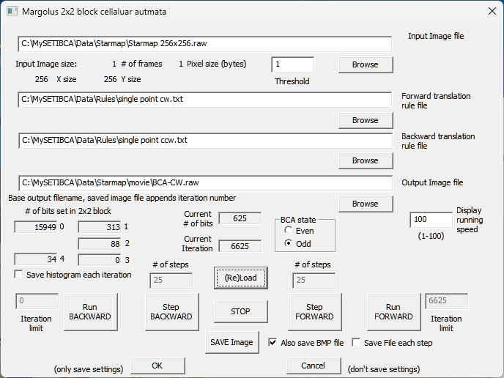

Click the '(Re)Load' button.

You will see the ‘starmap’ image.

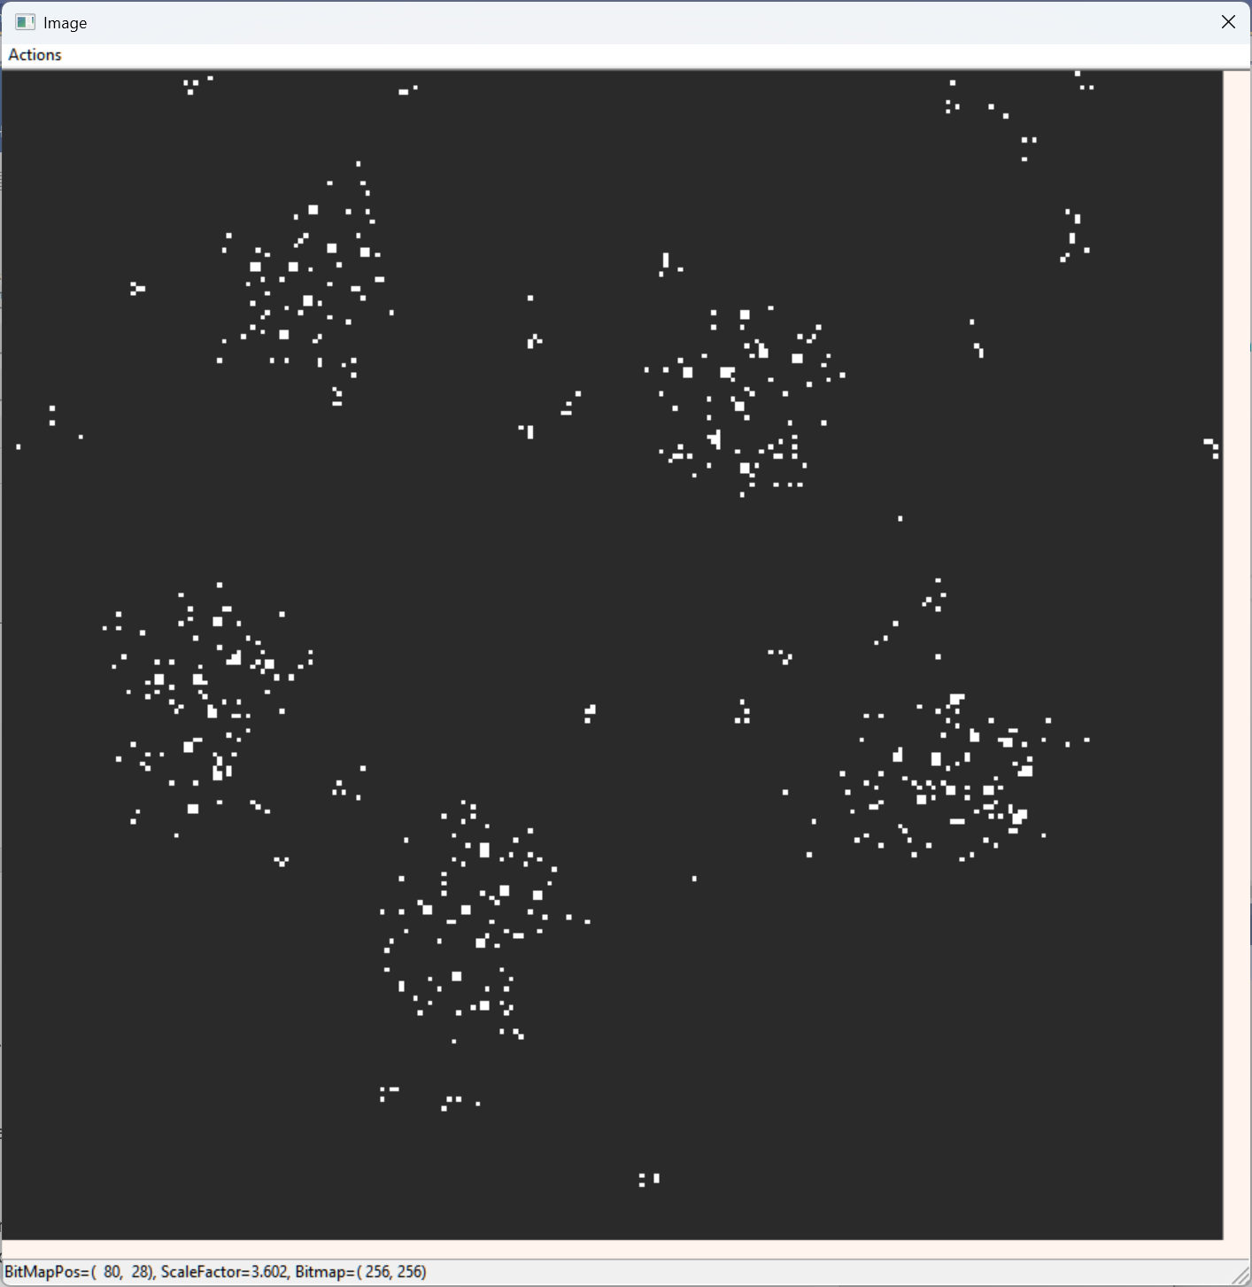

Click the Run Forward button.

When it stops you will see the decoded image.

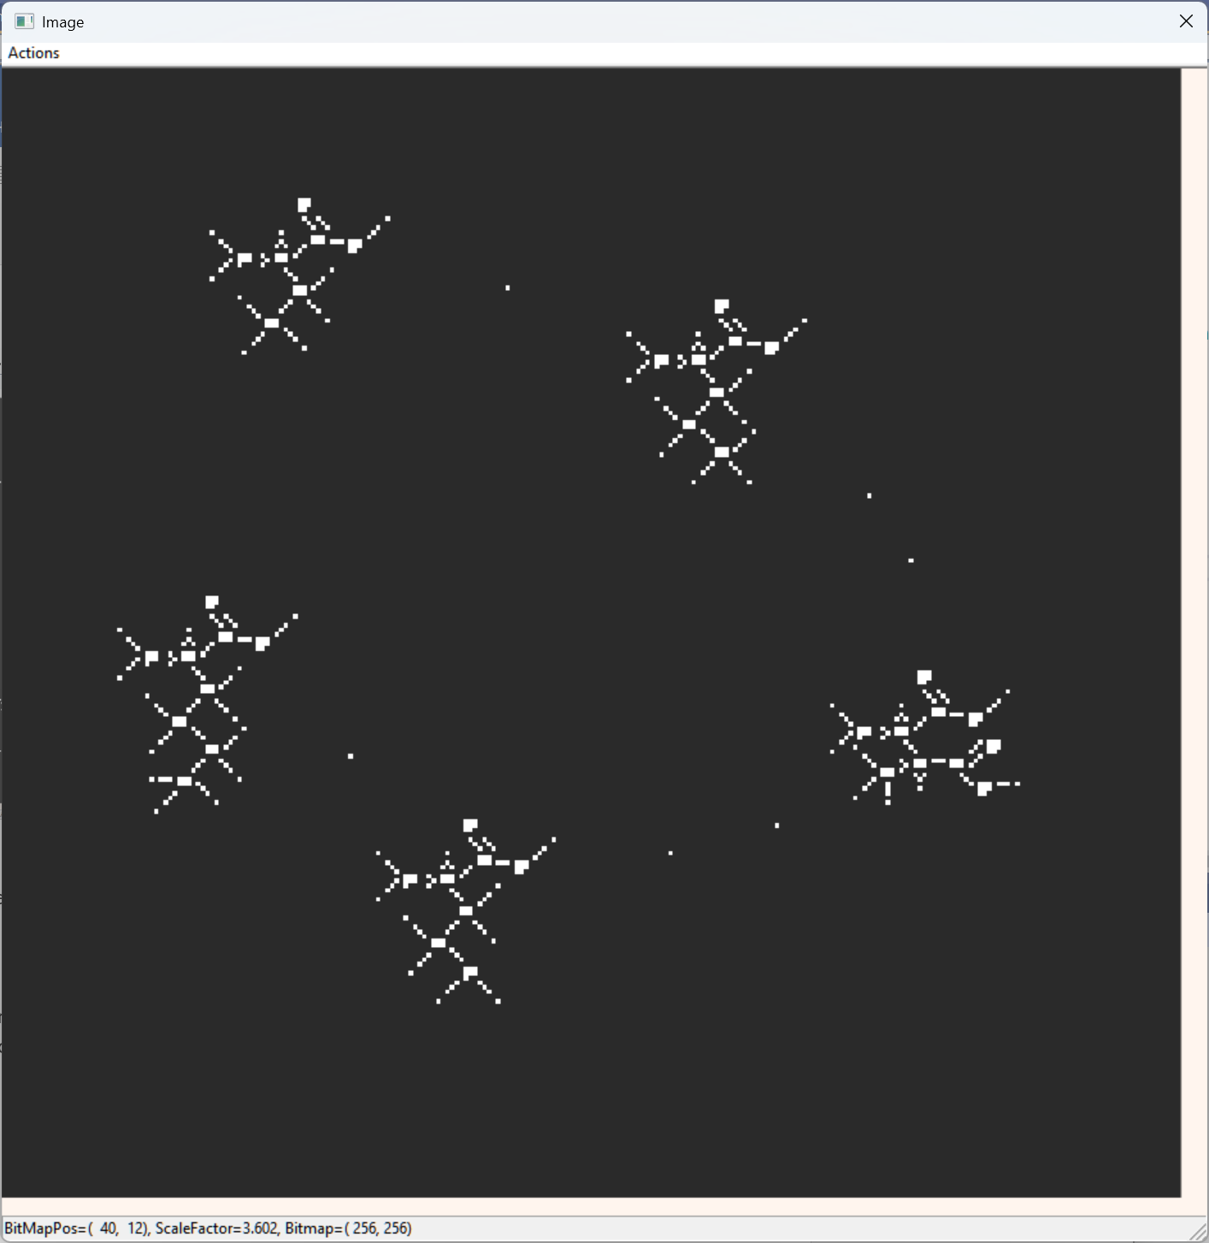

Adjust the image display to the size and zoom you want.

The ctrlkey+mouse scrollbar zooms in and out.

Left mouse button can be used to drag the image in the image display.

**Extracting the fully decoded image from the ASIS bit stream message, data17.bin**

This function applies all the extraction and applies the BCA decoding of the message in one step from the original message.

From the MySETIBCA app menu -> A Sign In Space -> Receive ASIS

Click OK to generate the fully decoded A Sign In Space Message

**If you want to start with the fully decoded ASIS message and transform it back into the ‘starmap’**

Use the following configuration in the 'Margolus 2x2 block cellular automata' dialog:

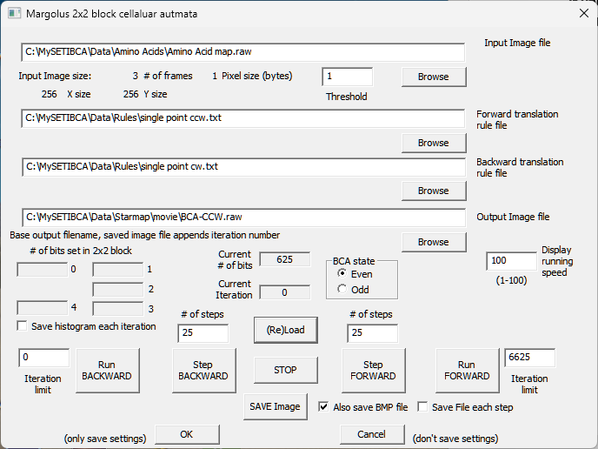

The input file is the fully decoded message.

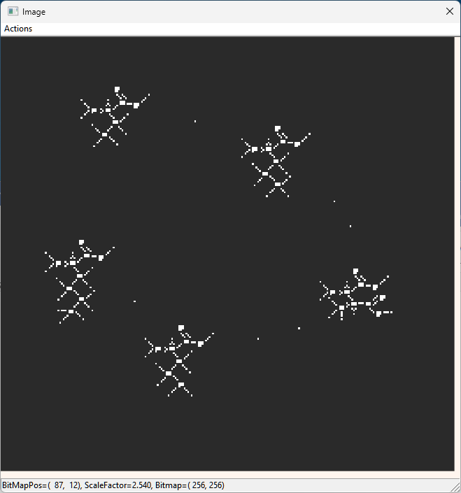

The forward and backward translation rules are revered.

Now when you run the BCA you will get the ‘starmap’.

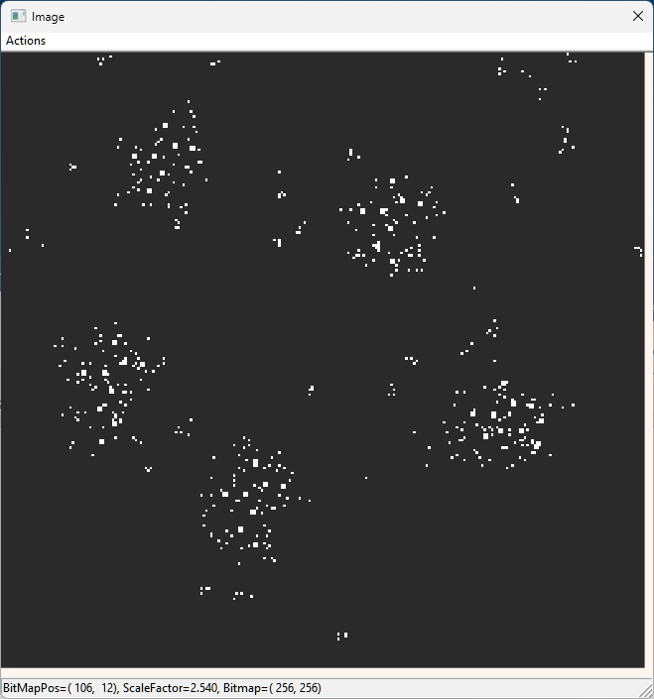

**Generate the original bitstream message from fully decoded message**

In the MySETIBCA app menu ‘A Sign InSpace’-> Send ASIS.

This will generate the original bit stream data file from the header, the fully decoded image and the 6625 iterations used in the encoding of the message.

All of this demonstrates the generation, decoding and regeneration of the message. This also enables someone to generate their own messages using the ASIS message format.